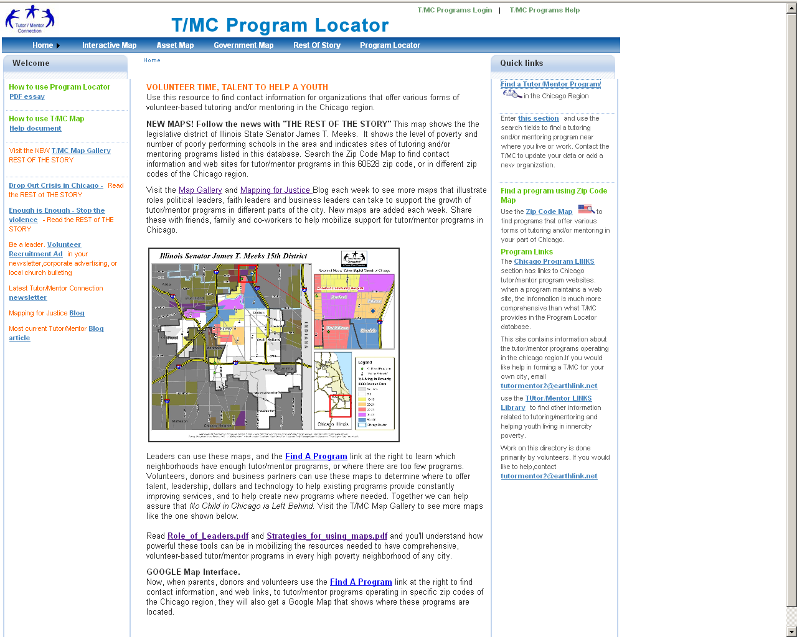

On the following pages I am providing new text for this home page of the Program locator.

- Center text area above and below map
- List at Left
- Text at right

VOLUNTEER TIME, TALENT TO HELP A YOUTH
Welcome to the Chicago Tutor/Mentor Program Locator. This web service is intended to help people in the Chicago region find information about non-school tutoring and/or mentoring programs operating in different parts of the Chicago region. It is also intended to help these non profit organizations get the volunteers and financial support each needs to provide effective services to youth in their areas. Finally, it is intended to serve as a planning tool to help businesses, faith groups and community leaders form new programs where none now exist.

Read the HOW TO pdf tutorials at the left to learn to use this resource. The more often you use it, the better you will understand how the features help volunteer-based tutor/mentor programs grow in neighborhoods where they are most needed.

USE MAPS TO BUILD COMMUNITIES OF SUPPORT FOR VOLUNTEER-BASED TUTORING AND/OR MENTORING PROGRAMS
Every two or three weeks we will feature a map below that shows a neighborhood which has been recently featured in Chicago newspapers, either because of an act of violence, activities of street gangs, or issues about poorly performing schools.

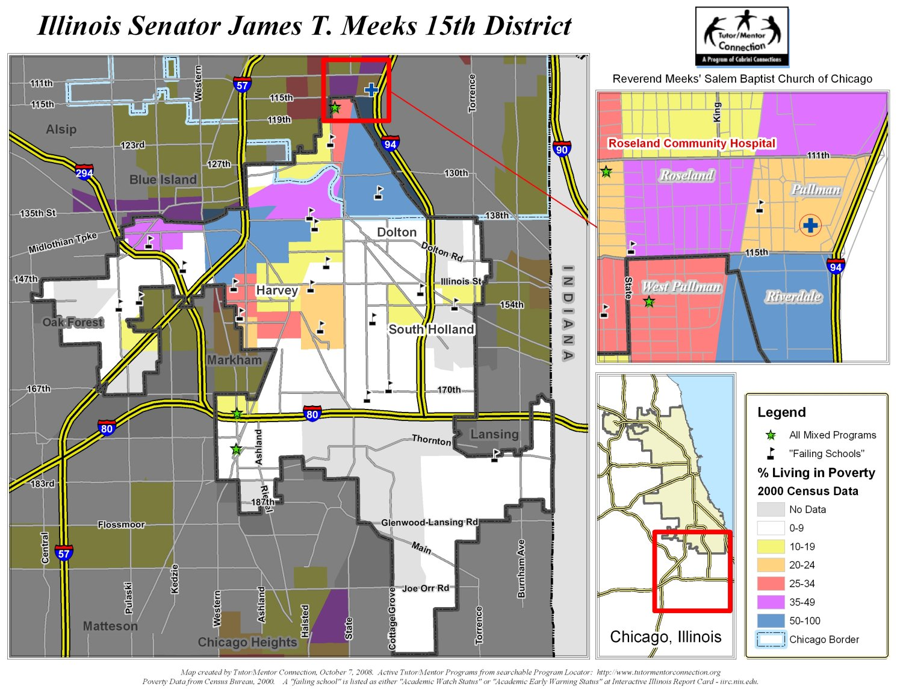
Ganesh, This map should have a HOT link to the REST OF STORY page of the Interactive map.
These maps will show the poverty and locations of poorly performing schools, which are indicators of a need for more adult support for the youth in the featured district. The maps will show locations of any tutoring and/or mentoring programs in the area, with contact information you can use to reach out to be a volunteer, or a donor, or to enroll a student.
Leaders can use these maps, the Interactive Maps and the Find A Program link at the right to learn which neighborhoods have enough tutor/mentor programs, or where there are too few programs. Volunteers, donors and business partners can use these maps to determine where to offer talent, leadership, dollars and technology to help existing programs provide constantly improving services, and to help create new programs where needed. Together we can help assure that No Child in Chicago is Left Behind. Visit the T/MC Map Gallery to see more maps like the one shown below.
Learn more about Tutor/Mentor Connection strategies and ways these maps can be used at the Tutor/Mentor Institute web site: http://www.tutormentorexchange.net
Left hand column:
Introduction to Program Locator
http://www.tutormentorprogramlocator.net/ProgramLocator/disclaimer.asp (Ganesh. Create new version of this page in the new format.)
How to use Interactive
T/MC Map Help document (see recommendations below)
How to add/update listing in
Program Locator database
http://www.tutormentorprogramlocator.net/ProgramLocator/program%20locator%20instructions.pdf (note this will need some revisions)
Mapping for Justice Blog
Most current Tutor/Mentor Blog article
How to use maps to build
neighborhood capacity:
http://www.tutormentorexchange.net/index.php?option=com_content&view=category&layout=blog&id=59&Itemid=111
Visit the T/MC Map Gallery
for library of T/MC maps
Latest Tutor/Mentor Connection newsletter

How to use Interactive
T/MC Map Help documentThis looks pretty good. The only change I would make is to put a screen shot with the descriptions of each map section. For example:
Asset Map
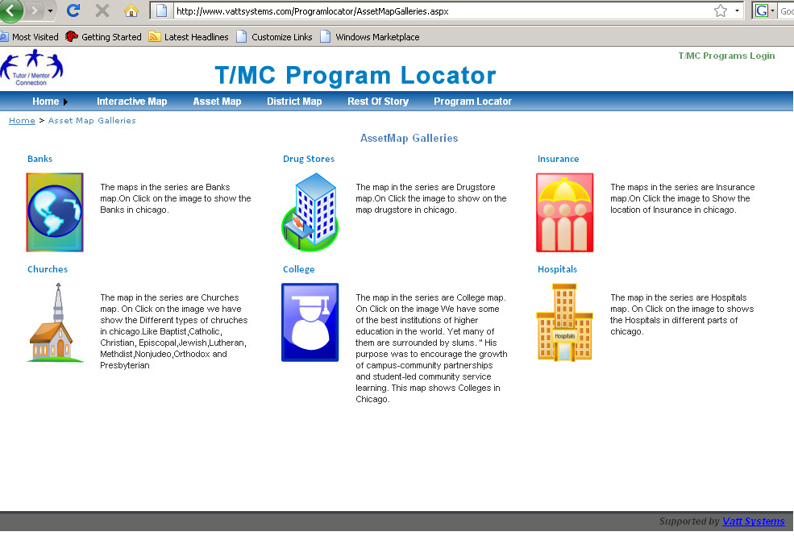
- Click on the menu (everything else in instructions stays the same)
----------------------------------------------
Government Map
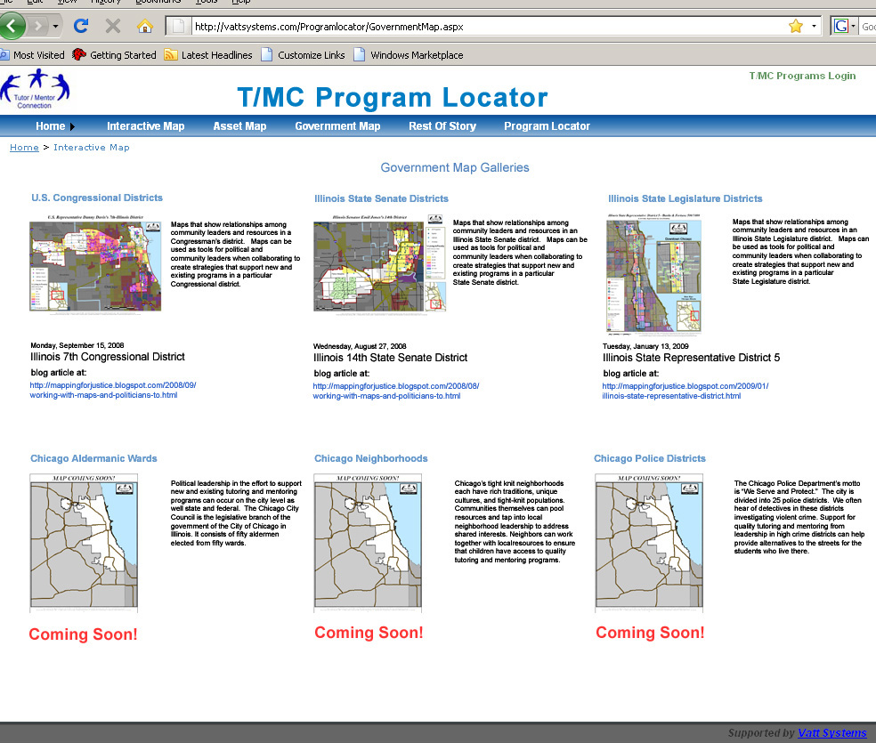
1) Click on the menu (everything else same)

